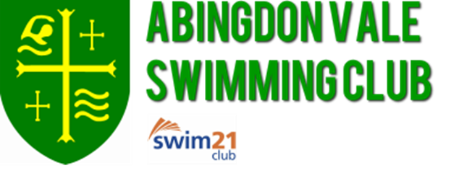

NATIONAL ARENA SWIMMING LEAGUE
Saturday 9th December 2017

I give permission for my child ...................................................................... to travel on the
AVSC team coach to Pringle Leisure Centre, Nuneaton

I will/will not be at the event

My emergency contact number will be ………………………………...............................................

Any medical conditions/allergies………………………………………................................................

Signed ………………………………...............................................

Date ………………………………..................................................

